Case Study – a large project involving Vegetation Data taken via satellite images over remote areas of East Africa.

Why is this data important?
The need to understand the Earth’s ecology and land cover is becoming increasingly important as the impacts of climate change start to affect animal and plant life, which ultimately affect human life. Knowledge of current vegetation trends and the ability to make accurate predictions is essential to minimize times of food scarcity in underdeveloped countries. Vegetation trends are also closely related to sustainability issues, such as management of conservation areas and wildlife habitats, precipitation and drought monitoring, improving land usage for livestock, and finding optimum agriculture seeding and harvest dates for crops. The United Nations has given attention recently to precipitation and vegetation monitoring in East Africa, where a severe drought hit the entire region in mid-2011. The drought has caused a food crisis across Somalia, Ethiopia and Kenya, threatening the livelihood of over 10 million people.

However, assessment of changes in a region’s vegetation structure is challenging, especially in topographically diverse areas, like East Africa. Forecasting future vegetation and agricultural planning become particularly difficult when unknown trends are occurring. For example, if a previously underdeveloped region is experiencing increasing trends in vegetation growth, meaning the land is able to sustain plant growth, local farmers could utilize this area to grow crops or raise livestock in future years. On the other hand, if a region is experiencing decreases in vegetation growth, this could be an indicator of over-farming, putting crops and livestock at risk of drought.

Data collection on vegetation and land cover are done through satellite remote sensing. The remote sensing imagery is used to convert the observed elements (i.e., the image color, texture, tone and pattern) into numeric quantities at each pixel in the image. The image pixels correspond to a square grid of land, the size of which depends on the satellite’s resolution. One such numeric value is the normalized difference vegetation index (NDVI). The NDVI has been shown to be highly correlated with vegetation parameters such as green-leaf biomass and green-leaf area, and hence is of considerable value for vegetation monitoring.

Data description

East Africa spans a wide variety of climate types and precipitation regimes which are reflected in its vegetation cover. To capture this, satellite imagery was collected over a sub-Saharan region of East Africa that includes five countries in their entirety (Kenya, Uganda, Tanzania, Burundi and Rwanda) and portions of seven countries (Somalia, Ethiopia, South Sudan, Democratic Republic of Congo, Malawi, Mozambique and Zimbabwe). This roughly rectangular” region extends from 27.8◦E to 42.0◦E longitude and 15◦S to 6.2◦N latitude. Also included in the region are several East African Great Lakes such as Lake Victoria, Lake Malawi and Lake Tanganyika.

The remotely sensed images were recorded twice a month from 1982–2006 and then converted to NDVI values. The NDVI scale, in this data set, ranges from 0 to 1000, indicating how much live green vegetation is contained in the targeted pixel. An NDVI value close to 1000 indicates more abundant vegetation. Low values of NDVI (say, 100 and below) correspond to scarce vegetation consisting mostly of rock, sand and dirt, for example. A range of moderate values (200 to 300) indicates short vegetations such as shrub or grassland; larger NDVI values can be found in rainforests (600 to 800).

Hence, the spatio-temporal data set consists of approximately 50,000 sites (pixels), each with 600 time series observations (24 observations per year over 25 years). The satellite’s resolution corresponds to each pixel spanning an 8 km ×8 km grid of land.

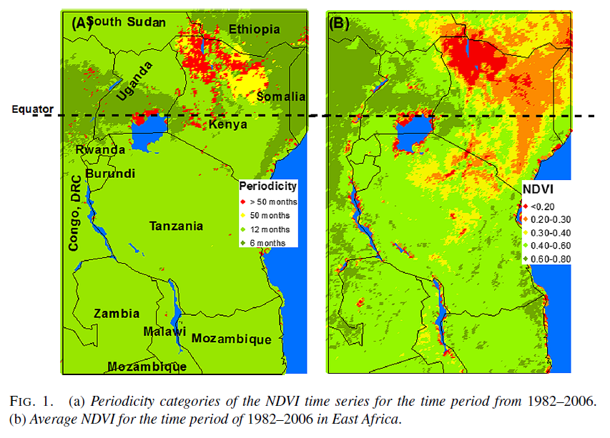

Figure 1(b) displays the average NDVI values for each grid point (site) over the region (rescaled 0 to 1). Blue areas indicate regions containing only water (Indian Ocean, Lake Victoria, etc.), and thus no vegetation index was recorded. The light and dark green areas have more green vegetation on average compared to the drier areas, represented with yellow, orange and red. In this figure, one can see how this East African region spans the NDVI scale. Desert regions (with low NDVI) are within a few hundred kilometers of wetlands and rain forests (with extremely high NDVI), illustrating the large variability of climate types and precipitation regimes in this region.

Figure 2 shows the time series plots for two selected pixels. The top series is a pixel selected from Southern Kenya and has a unimodal periodic pattern. The bottom series of Figure 2 is a pixel selected from the Democratic Republic of the Congo and has a bimodal periodic pattern.

